ABHIVRIDDHI Electronics

Our Abhivriddhi utilize power of two 250W Geared DC Motor for the locomotion and one power window motor which is used in car windows. The motor which we have used is from HONDA CIVIC.

Motor used for locomotion:

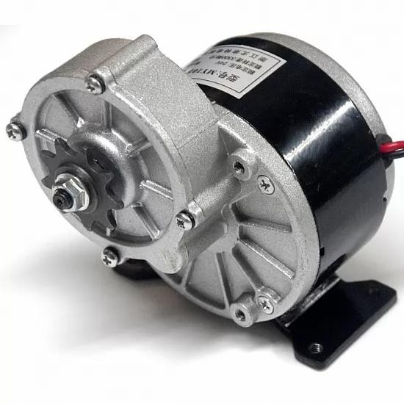**MY1016 250W 24V DC Motor**

This motor is small brush motor and meets our needs. This chosen motor have following specifications:

1. Rated output Power 250W
2. Rated Voltage 24V DC
3. Rated speed3000RPM
4. No load speed 3850RPM
5. Full load Current ~13.4A
6. No load Current ~2.2A
7. Rated Torque8.0N.m
8. Efficiency ~78%

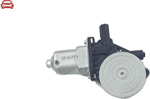**Honda Power Window Motor**

Specifications:

1. Rated Voltage: 12V DC
2. No load current: 2.15
3. Full load current: 15A
4. No load speed: 110 rpm
5. Full load speed: 100 rpm
6. Stall torque: 7.68

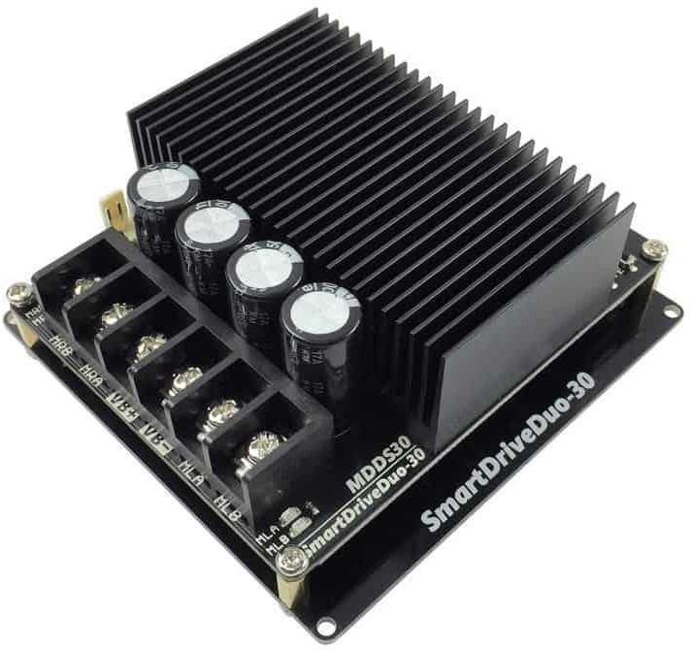Features of [SmartDriveDuo-30](https://www.cytron.com.my/p-mdds30):

* + Bi-directional control for dual brushed DC motor.
  + Support motor voltage from 7V to 35VDC.
  + Maximum current up to 80A peak (1 second), 30A continuously, each channel.
  + On board MOSFETs are switched at 18kHz for quiet operation.
  + Battery low voltage indicator.
  + Battery over voltage indicator.
  + Thermal protection.
  + **Current limit protection.**
  + Multiple input modes: RC, Analog/PWM, Serial Simplified and Serial Packetized.
  + **GROVE compatible connectors for control input.**
  + RC (Radio Control) friendly

connectors.

* + On board push buttons for fast test and manual operation.
  + On board LED indicators for Error, RUN, over current, motor output, for each channel.
  + 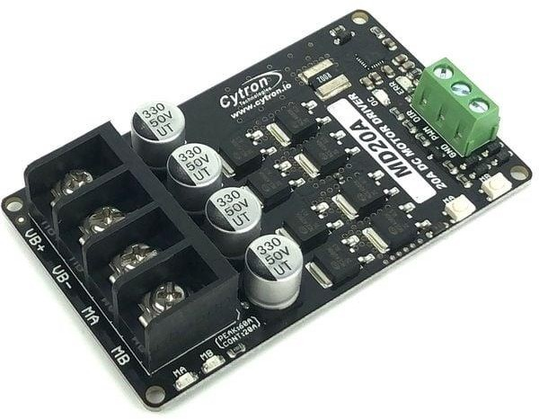Dimension: 81.28mm (W) x 101.60mm

(L) x 42mm (H)

Cytron 20 Amp 6V-30V DC Motor Driver MD20A

1. Bidirectional control for one brushed DC motor.
2. Operating Voltage: DC 6V to 30V
3. Maximum Motor Current: 20A continuous, 60A peak
4. Buttons for quick testing.
5. LEDs for motor output state. Overcurrent protection with active current limiting.
6. Temperature protection.
7. Undervoltage shutdown.

One of the mechanisms on our bot is delta arm robot which is made by using servos. We have selected 60kgcm servo for our mechanism. Specifications of the servo are as follows:

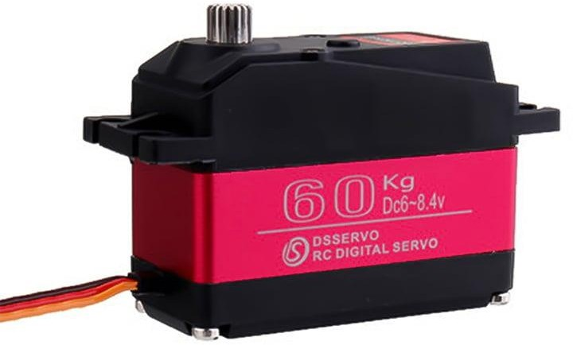Ultra-Torque Quarter Scale 60kgcm Metal Gear Servo Motor

* 1. Operating voltage: 6 V to 8.4 V
  2. Durable Metal Gear
  3. Dual Ball Bearing
  4. Programmable Digital Amplifier with Mosft Drive
  5. Bottom Side Axial Mount Hole
  6. Less Noise
  7. Gear Type: All Metal Gears
  8. Stable and shock proof double ball bearing design
  9. Operating Angle: 180 degrees

To spray the fertilizers and water, the spray mechanism is developed such it will have 90 degrees of motion. For providing this motion 35kgcm rated torque servo is selected. This motor can also provide actuations for any other intermediate angles.

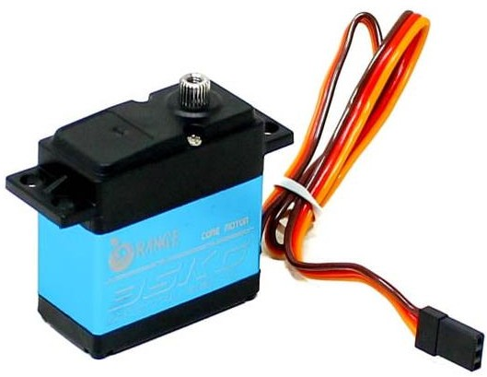Orange OT5330M 7.4V 35.5kg.cm 180° Metal Gear Digital Servo Motor

* + 1. Input Voltage Range (VDC): 4V-8.4V
    2. Rated Torque: 35.5Kg.cm @ 7.4V
    3. Gears Type: Steel Metal
    4. Connector: JR
    5. Command Signal: PWM
    6. Size (L x W x H) mm: 55 x 20 x 43

This was all about the motors for actuations but for providing the proper voltage and current to the spray mechanism and delta robot step down buck converters are used. The specifications are as follows:

*Features:*

* + - 1. 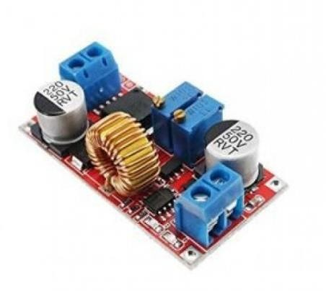Short circuit protection: Yes(limited current 8A)
      2. Over-temperature protection: Yes (automatically turn off the output after over temperature)
      3. Input reverse connection protection: None, (If necessary, please input a large current diode in the input string)
      4. Installation method: 4 3mm silk
      5. Wiring method: terminal block or soldering terminal,
      6. V-IN is input.